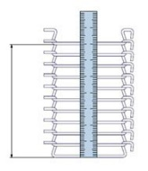

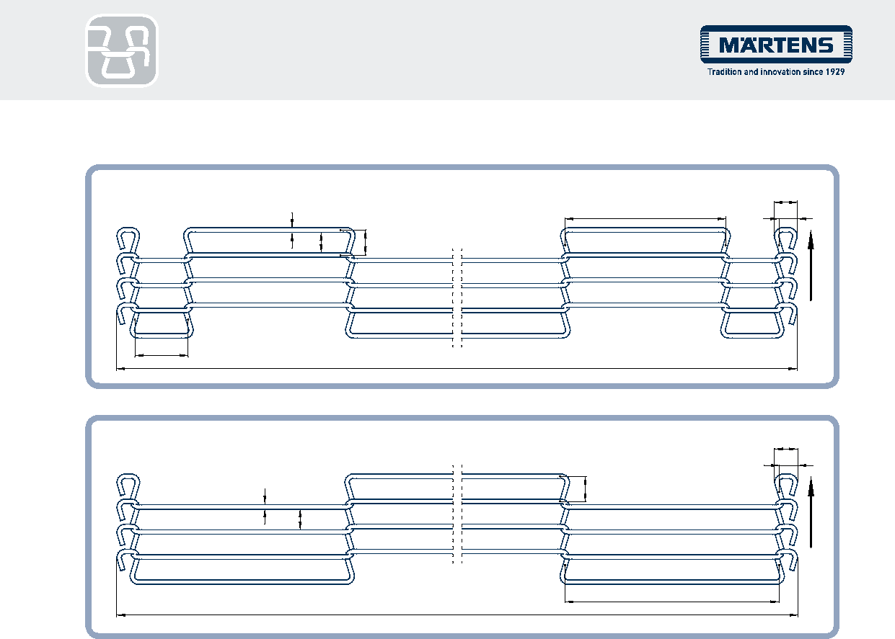
ROD NETWORK BELT –
ECO PRODUCT INQUIRY
H
Rod net work belt with gear wheel edge
E
G
A
H
Rod net work belt without gear wheel edge
C
E
D C
Direction of running
F
B
G
Direction of running
D
B
A
A Wire +Ø/mm D Mesh width/mm G Final loop dimension
B Width/mm E Mesh length/mm H Final loop/external/mm
C Pitch/mm F Gear wheel edge/mm
Måles over 10 afstande, se tegning til højre
A Wire Ø [mm]
B Width [mm]
C Pitch** [mm]
D Mesh width* [mm]
E Mesh length [mm] Mesh number
F Gear wheel edge [mm]
G Final loop / interior [mm]
H Final loop exterior [mm]
If there is a need for special shapes such as tips, humps, depressions or cam profiles, we will be happy to advise you in person
. (*This dimension is not mandatory. ** to get the best result measure over 10 pitch, when the belt is on the machine and under tension)
Material Spring steel wire Stainless steel wire K2390
Desired belt length / offer volume

