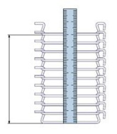
A Wire +Ø/mm D Mesh width/mm G Final loop dimension
B Width/mm E Mesh length/mm H Final loop/external/mm
C Pitch/mm F Gear wheel edge/mm
Måles over 10 afstande, se tegning til højre

A Wire Ø [mm]
B Width [mm]

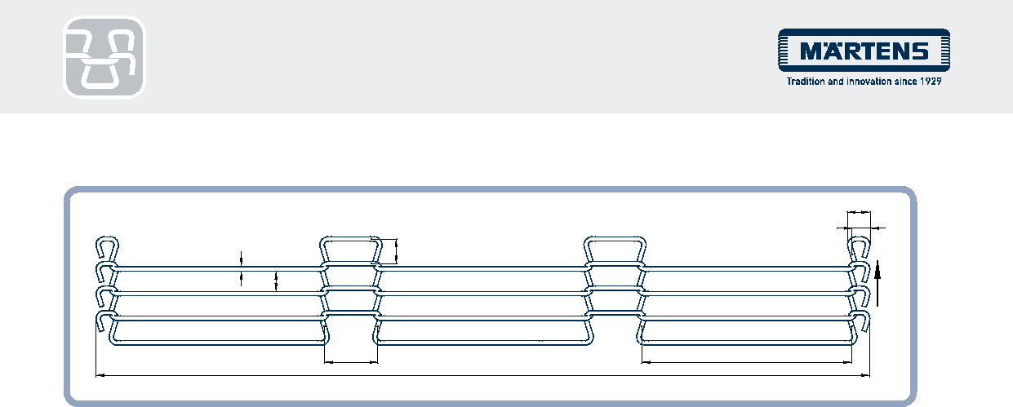
ROD NETWORK BELT –
ELT PRODUCT INQUIRY
H
G
C
A
D
Direction of running
E2
E1
B
C Pitch** [mm]
D Mesh width* [mm]
E1 Length long mesh [mm] Mesh no.
E2 Length short mesh [mm] Mesh no.
G Final loop / interior [mm]
H Final loop exterior [mm]
If there is a need for special shapes such as tips, humps, depressions or cam profiles, we will be happy to advise you in person.
(*This dimension is not mandatory. ** to get the best result measure over 10 pitch, when the belt is on the machine and under tension)

Material Spring steel wire Stainless steel wire K2390

Märtens article no. (if known) _____________________________________________________________________________________________________________
Desired belt length / offer volume __________________________________________________________

